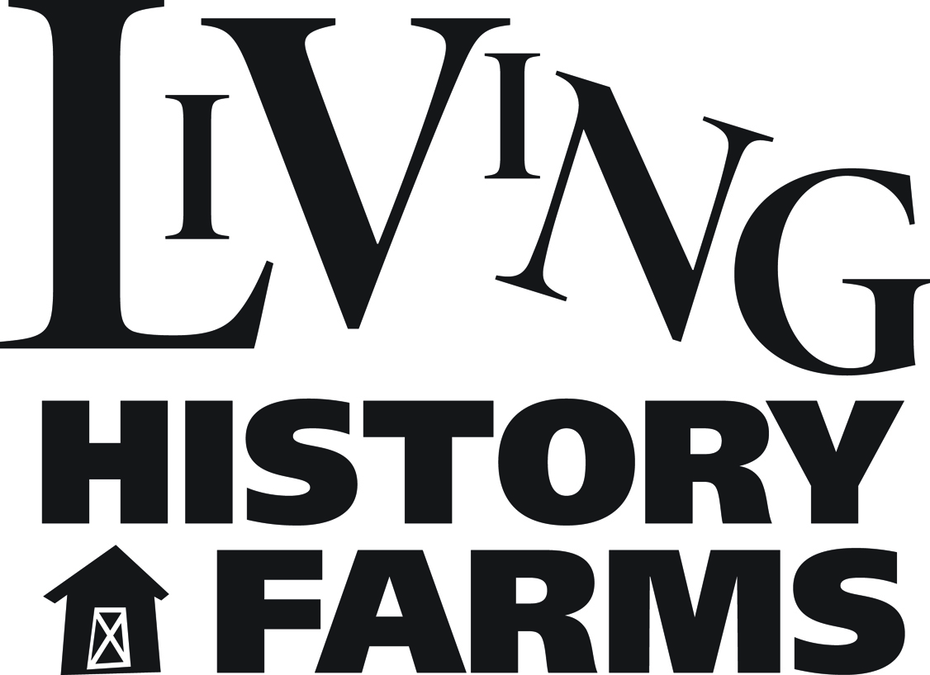

LIVING HISTORY FARMS JOB POSTING

Position Title: Sponsorship and Events Associate
Position Classification: Full-Time, Non-Exempt
Department: Development
Reports to: Vice President, Development

Job Summary:
The Sponsorship & Events Associate has primary responsibility for securing sponsorships for LHF events. This involves developing an annual sponsorship plan, researching potential sponsors for LHF events, preparing sponsorship requests and meeting with prospective sponsors. In addition, the Sponsorship & Events Associate also has responsibility for planning the museum’s annual gala and for donor/member cultivation events.
Duties:
- In conjunction with the Vice President, Development and other members of the Development team, develops an annual sponsorship plan.
- Works with Manager of Community Events and Vice President, Development to identify potential event sponsors and partners. Takes the lead in securing those sponsors and partners.
- Develops and implements plans for Farmstasia, the museum’s annual gala. Seeks out and secure sponsors and stewards those sponsorship relationships.
- Coordinates with Development Officer to communicate sponsorship fulfillment obligations to appropriate LHF staff to ensure compliance with all sponsorship obligations (e.g., recognition). Looks for opportunities to deliver more than promised. Reports back to sponsors regarding fulfillment and the impact of their support.
- Works with Manager of Membership and Guest Services to develop member benefit events/programs (e.g., Member Mondays). Works with other staff, as appropriate, to develop content for these events/programs. Takes the lead in implementing/managing them.
- Works with Manager of Community Events to develop plans for promoting facility rentals of and group visits to the museum. Takes the lead in promoting these opportunities to corporate groups, senior clubs, etc.
- Writes grant proposals and reports.
- Serves as an active and contributing member of a team-based work environment, including as a member of the Development Team.
- Other duties as assigned.

Qualification and Skills:
- Bachelor’s Degree preferred
- Sponsorship or events experience preferred
- Experience in development or a related field a plus.
- Demonstrated excellent communication (verbal and written) and interpersonal skills required.
- Exceptional attention to detail and demonstrated ability to meet deadlines required.
- Core computer skills in word processing, spreadsheets and electronic communications required.
- Must be a strong collaborator, able to work well in team environments.
- Demonstrated excellent customer service, communication and interpersonal skills required.

Position Status:
Classified as non-exempt full-time (benefits eligible). Typical schedule is Monday through Friday, with an occasional evening or weekend event.

General Information:
Living History Farms is an interactive outdoor museum which educates, entertains and connects people of all ages to Midwestern rural life experiences. It is a privately run, not-for-profit organization on 500 acres located in Urbandale, Iowa. Historical interpreters dress in period clothing and recreate the daily routines of early Iowans on three farm sites spanning the years 1700-1900 and an 1875 town. More than 100,000 guests visit Living History Farms annually, one third of who are associated with school visits or educational programs. The season typically runs approximately May 1 - October 15. For more information, please visit www.livinghistoryfarms.org

Application Process:
Please send resume, cover letter and completed application (form found on LHF website) to:

Jim Dietz-Kilen
Vice President, Development
jdietz-kilen@lhf.org

Position is open until filled.

Updated: October 2016

