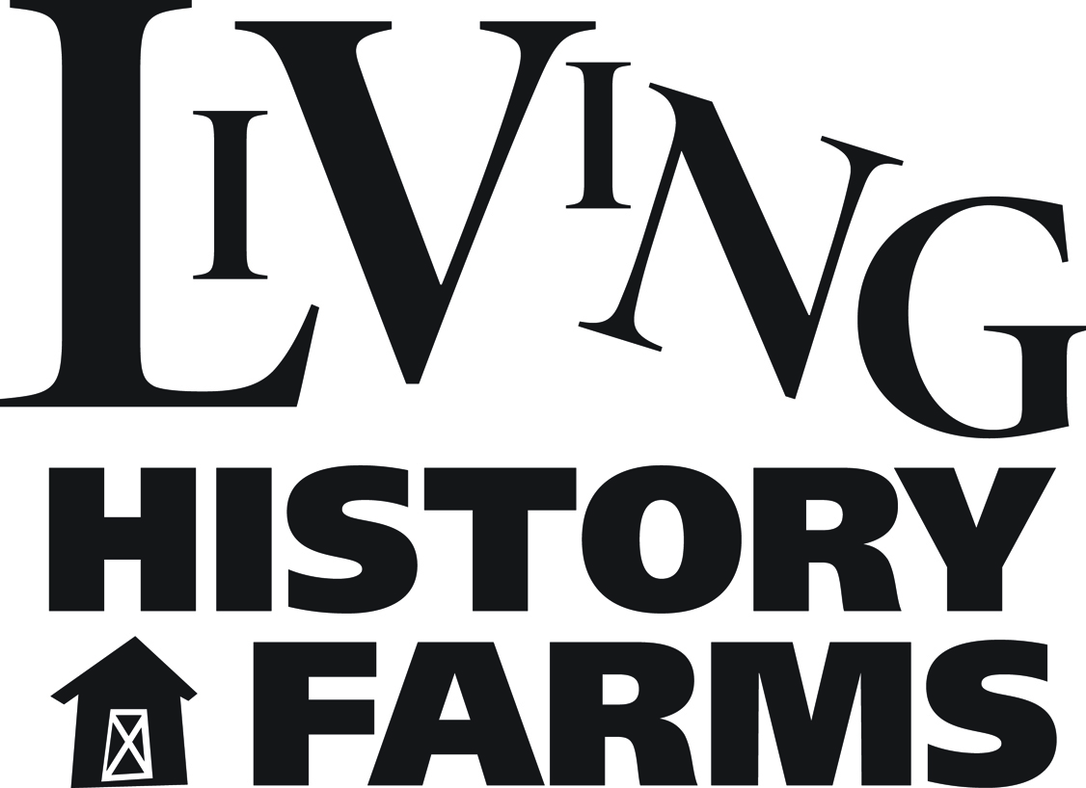

LIVING HISTORY FARMS JOB POSTING

Position Title: Development Officer
Position Classification: Full-Time, Non-Exempt
Department: Development
Reports to: Vice President, Development

Job Summary:
The Development Officer has primary responsibility for management of Living History Farms’ donor database program (The Raiser’s Edge), direct mail fundraising, gift processing and gift fulfillment.

Duties:
- Manages the LHF donor database, The Raiser’s Edge. This includes data entry of gifts, gift tracking and reporting, along with recording significant donor interactions and information.
- Assures that gifts and commitments are tracked and acknowledged in accordance with the donors’ intentions.
- Prepares and manages annual fund direct mail plans and budget.
- Performs maintenance tasks for The Raiser’s Edge
- Maintains electronic and paper donor files
- Answers general development inquiries (phone and email) and routes inquiries, as appropriate
- Coordinates gift processing and reconciliations with Finance Department.
- Assists with Fundraising Events including LHF’s signature fundraising event, Farmstasia.
- Assists with grant proposals and reports to donors
- Maintains and updates www.LivingHistoryFarms.org giving/support pages.
- Other duties as assigned

Qualification and Skills:
- Bachelor’s Degree preferred
- Fundraising Database experience preferred
- Experience in development or a related field a plus.
- Demonstrated excellent communication (verbal and written) and interpersonal skills required.
- Exceptional attention to detail and demonstrated ability to meet deadlines required.
- Core computer skills in word processing, spreadsheets and electronic communications required.
- Must be a strong collaborator, able to work well in team environments.
- Demonstrated excellent customer service, communication and interpersonal skills required.

Position Status:
Classified as non-exempt full-time (benefits eligible). Typical schedule is Monday through Friday, with an occasional evening or weekend event.

General Information:
Living History Farms is an interactive outdoor museum which educates, entertains and connects people of all ages to Midwestern rural life experiences. It is a privately run, not-for-profit organization on 500 acres located in Urbandale, Iowa. Historical interpreters dress in period clothing and recreate the daily routines of early Iowans on three farm sites spanning the years 1700-1900 and an 1875 town. More than 100,000 guests visit Living History Farms annually, one third of who are associated with school visits or educational programs. The season typically runs approximately May 1 - October 15. For more information, please visit www.livinghistoryfarms.org

Application Process:
Please send resume, cover letter and completed application (form found on LHF website) to:

Jim Dietz-Kilen
Vice President, Development
jdietz-kilen@lhf.org

Position is open until filled.

Updated: October 2016

